Book state not changed even after the loaner state changes after giving fine

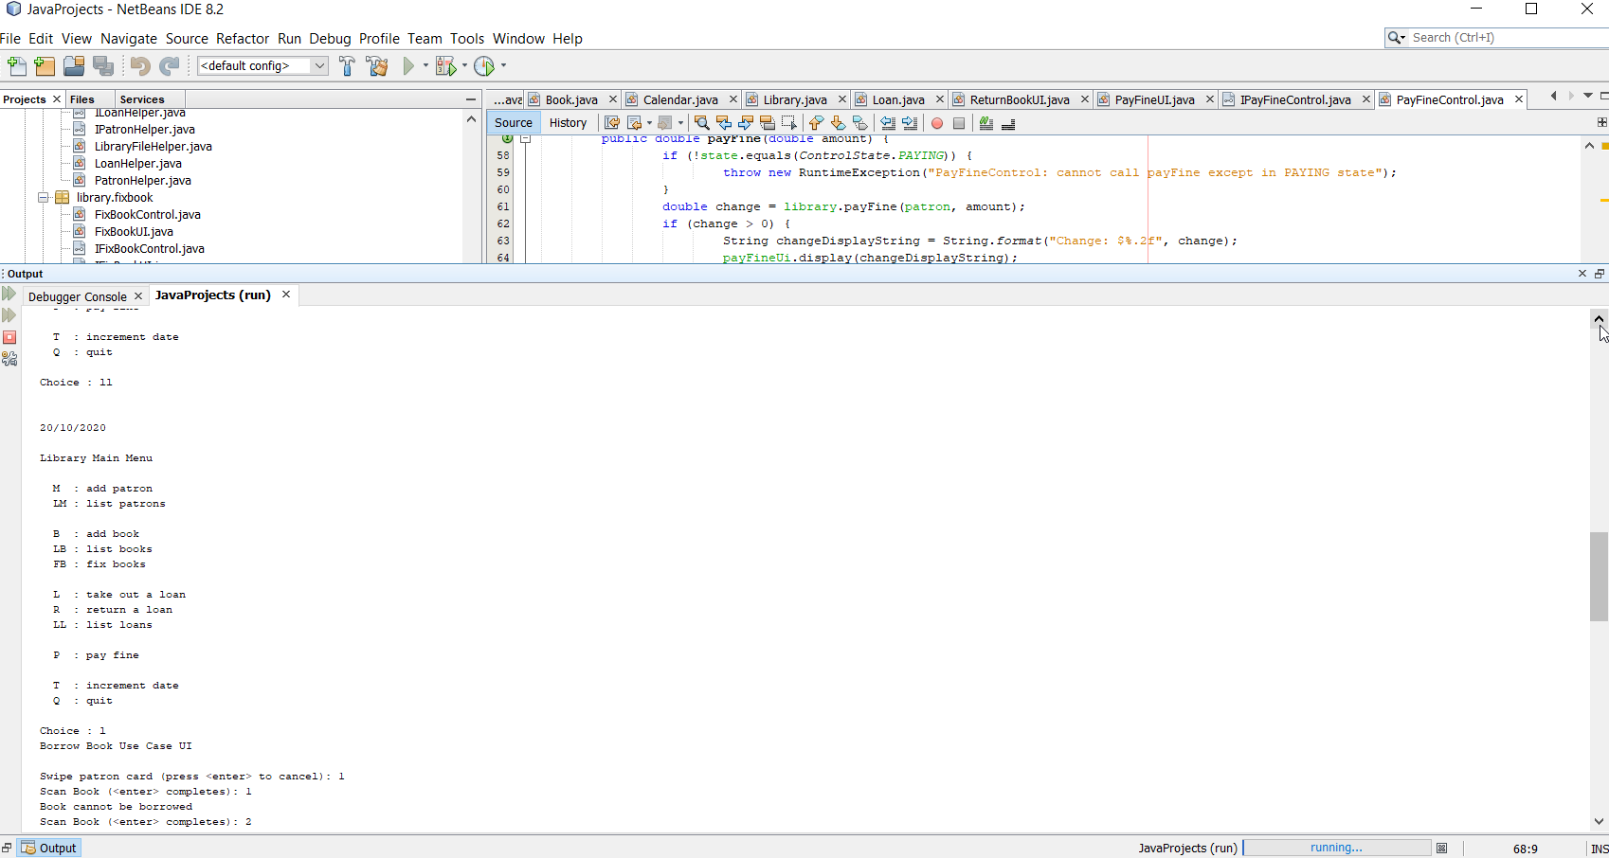

Book state is not checked in case of parallel borrowing of the same book.

